**Unschool**

**C and C++ assignment**

**Name:- Vaidehi Dayaram Dahare**

**E-mail:-** [**Vaidehidahare06@gmail.com**](mailto:Vaidehidahare06@gmail.com)

**Q1:- Write a programme to calculate the sum of three integers.**

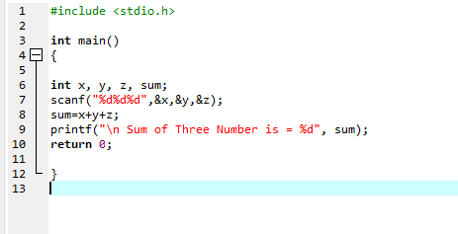

**Output:-**

